*The* ***black****,* ***red*** *and* ***gold*** *colors featured in this issue honor the flag of Germany, country of the month in the “Around the World” program. The masthead cameo is an AI-generated elderly* frau *wearing a dirndl celebrating Oktoberfest. Four residents contributed articles on Germany.*

***Heritage Happenings***

***October 2024***

*The monthly newsletter published by residents of*

*Heritage on the Marina, San Francisco CA, USA*

## Events of Note

* The annual bus excursion to the best picnic spot in Samuel P Taylor Park in Marin County takes place on Thursday, October 10. Dining Services will host a barbecue with delectable food and delicious drinks.
* Marty Nolan will be honored with a reception on Wednesday, October 23 at 3:00 in Morgan Parlor. The Sacramento Seminar Club will present Marty with a book of interviews by UC Berkeley Bancroft Library.
* See the details on page 18 for the Doris Howard Art Exhibition.

## Hector Arrazola ~ Director of Maintenance

* International Shakeout is on October 17. People worldwide participate in earthquake drills at work, school, or home! See www.shakeout.org.
* New fire alarm panel: Installed and tested
* Loudspeaker system: Proposals submitted, presently under review
* Loading Dock Safety Repair: 95% completed
* Apartment #213 & #327: Refresh demolition started
* Apartment #423: Laundry room conversion: Wait city approval
* Morgan Building Elevator: Waiting on architects’ final drawings
* Perry & Morgan Stairs Chair Lifts: First install chairs lifts to 1st floors only. Need inspection and approval by city inspector for project approval before installation on remaining floors

# Martha Nkhoma ~ Director Resident Health Services

* Flu vaccine clinic scheduled for Tuesday, October 29, 10am to 2pm
* Starting October 1, the Resident Health Services team is conducting the annual tuberculosis testing for all residents to meet RCFE requirements and ensure the safety of all community members. Sign up in the Corridor

# Bob Connoly ~ Senior Sales Manager

* We welcomed new residents Val Szigeti and Tom King
* An application received for 1530 Francisco with a move in October
* October occupancy looking like 90%!
* Ads are now in *Marina Times*, St Vincent De Paul, Stanford & Cal monthly alumni magazines and SF Chronicle senior edition (next month)
* The centenary of the Julia Morgan Building will be celebrated on Wednesday, March 25, 2025. We are planning for a gathering of San Francisco dignitaries, directors, team members and residents

## Message from Patrick Alexander ~ Resident Council President

**Employee Appreciation Fund:** It is time to start thinking about your contribution to the Employee Appreciation Fund. We don’t tip staff on a daily basis, but as you know we reward them for their service at the end of the year. On October 1st we will be sending out a leaflet giving instructions about contributing to the Employee Appreciation Fund. Please be generous!

## Mary Liz Harris ~ Food Committee Chair

The Food Committee met on September 10, 2024. We discussed comments and will continue to gather more feedback. Meeting highlights:

* We can no longer get basa fish. Tilapia and cod are now served.
* Meals praised include the French dinner with bouillabaisse and house made eclairs and the Spanish dinner with paella, salad and flan
* Special meals for October include Samuel P Taylor BBQ 10/10, German Themed Oktoberfest dinner 10/18, Halloween themed meals 10/31
* Birthday dinner will be on October 11 hosted by Mary Linde
* Kayla Vaglio, registered dietitian, is coming October 12 for a teaching kitchen followed by lunch and learn
* Friday October 25 is milkshake day; Superfood for October is **pumpkin**
* The next Food Committee meeting is on November 12

|  |  |
| --- | --- |
| ***Heritage Happenings*** The monthly publication published by residents of [Heritage on the Marina](https://heritageonthemarina.org/).  **Editor Emerita**  Margaret Jacobs  **Editor**  Theo Armour  **Associate Editor**  Mia Cotton Harlock  **Editorial Committee**  Jane Standing  Martha Nell Beatty  Doris Howard  Margaret Missiaen  **Reporter at Large**  Trish Otstott  **Proofreader**  Midge Mansouri  **Web**  [heritage-happenings.github.io](https://heritage-happenings.github.io)  **General Disclaimer**  The views and opinions expressed in this publication are those of the authors and do not necessarily reflect the official policy or position of Heritage on the Marina.  © 2024 *Heritage Happenings* authors.  No rights reserved. | Transformations in Participation Long-time residents of Heritage on the Marina often reminisce about the days when participation in activities seemed more vibrant. Out and About excursions bustled with eager participants, residents enthusiastically planned and hosted parties, and the art room hummed with creativity.  **Shifting Demographics and Interests**  Our community has naturally evolved. The average age has climbed to over ninety, bringing a shift in interests and energy levels. Many of our residents now find contentment in the comfort of their apartments, enjoying quiet walks, or perhaps indulging in a few hands of solitaire on their laptops. ;-)  **A Different Kind of Engagement**  The change doesn't signify a lack of community involvement. Rather, it represents a transformation in how residents participate. The September Heritage Happenings Newsletter, Calendar, and Resident Directory reveal a surprising level of engagement.  **By the Numbers**   * Total pages produced: 46 * Number of contributors: 24 residents and team members combined + one cat * Current resident population: 77   Nearly one-third of our residents were directly involved in creating community documents!  While the nature of participation may have shifted, the spirit of community involvement remains strong. Residents continue to contribute in meaningful ways, adapting to their changing needs and preferences.  As we move forward, let's celebrate this evolution and continue to find new and engaging ways for all residents to participate in our always evolving community life.  Theo Armour |

# Meet Vada Watson ~ Assistant Director of Resident Health Services

By Martha Nell Beatty

Raised in small-town Ohio, Vada was the oldest of seven. She was the only child of her parents until eight, when her first half-sibling was born. She is 27 years older than her last sibling. She also had godparents she was close to, and their children were almost like siblings.

In her junior year of high school, Vada was able to start nursing studies and before she was 17, Vada amazingly qualified as a certified nursing assistant (CNA). Her first job in nursing was in a geriatric facility, where her mother was head cook. At 18, she qualified as a licensed vocational nurse (LVN). Her first job as a nurse was in a geriatric psych facility. At the same time, she started studies at the University of Akron in 2012. After a couple of years of nursing and college, Vada decided to join AmeriCorps, a domestic version of the Peace Corps. She was boots on the ground in disaster relief with FEMA. She particularly remembers being all over Texas in 2015, when there were massive floods. Vada determined she wanted to finish her BA in social work, so she returned to Ohio to complete her studies and finished her BA in 2018.

After getting her degree Vada moved to working in child services, where she was an in-take specialist. That meant knocking on doors of homes were there were allegations of child abuse or assault. During her time there, she was trained as a forensic interviewer focused on addressing potentially challenging abuse cases. Then Vada moved to Virginia Beach in 2019, where she used her licensed vocational nurse (LVN) and social work training.

In 2021, Vada moved to San Francisco at the height of Covid. She got a job with San Francisco Community Clinic Consortium and found herself in the middle of the Tenderloin with tent-lined streets. She was a program manager and part of her duties were hiring staff and coordinating volunteers. The group was made up of medical staff and volunteers who provided outreach to the unhoused. Partnering with obstetric providers, they started a maternal health program that reached out to pregnant unhoused women who were “lost to service.” They also started a pilot program in geriatrics focused on connecting clients to primary care.

While she was with the Consortium, Vada got her MA in public administration in September of 2022. After the two-year program, she moved on to a job with Bay Area Community Services, which is predominantly in the East Bay. The group provides psychiatric medical management for those who are unhoused or partially housed. Vada had been working in street medicine for over two years and realized she was burnt out although the experience was remarkable. “You can only spend so much time watching people where you can’t fix things.”

She transitioned back into geriatrics working for Morningstar in San Jose. Not being from the area, Vada did not calculate that it might take two and a half hours one way to get to her job from the East Bay. Commuting to Heritage on the Marina from the East Bay seems really easy. And we’re so lucky to have her here.

And in her spare time: Vada sews clothes, makes jewelry, and quilts. She has a passion for hiking as well as photography. Vada has had showings in galleries, the most recent being in a Lower Haight gallery. She is also a prolific reader and was pleased she completed Stephen King’s *Dark Tower* series.

Time for sleep? Let’s hope Vada works that into her days.

# Oktoberfest in Germany

By Tucker Ingham

*AI-generated image based on the text of this article*

I was running as fast as I could, but that German waiter was still after me, my one-liter *hofbrau* mug still in hand. He was probably twice my age, it was Oktoberfest, and he was only doing his job, trying to catch a 21-year-old skinny American wise guy. My college roommate and I had been directed to a table with four beefy middle-aged münchenites, all of whom spoke American vernacular lingo with ease because, as they told us cheerily, they had been sent as POWs to Texas. They loved us. So, the question looms embarrassingly, why on God's green earth are we so often at war with such good beer-drinking neighbors?!!

Will and Ariel Durant, after 35 years of recording much of world history, write that the perennial answer will always be a combination of pride, acquisitiveness, and pugnacity.

The waiter behind me exemplified those attributes of hostility: He was proud of his job, acquisitive of the beer stein, and ready to be pugnacious. But then, so was I, proud, acquisitive, and insultingly pugnacious by my theft. The waiter would be mollified if I surrendered the mug, but he was by now on his way back to his job, and I was left with feeling society's collective guilt and dismay, beer stein or not. And perhaps we should, some of us anyway, really be ashamed of ourselves. Sometimes.

# *Der Mauerfall* ~ The Fall of the Wall

By Trish Otstott

I’d been there just before.

As a flight attendant for TWA, one of my favorite routes was to Berlin. To practice my German, I took a long cab ride to visit my favorite spots and chat with the driver. We stopped at the Brandenburg Gate, taking in the stark divide between East and West.

The East was desolate and grim with razor wire and militant guards patrolling bare streets. Meanwhile, on our side of the wall, life was flourishing with verdant linden trees, interesting buildings, and the bustle of West Germans going about their day.

No one knew the wall was coming down, so imagine my surprise three weeks later—in November 1989—when I approached Brandenburg Gate.

No razor, no guard patrol. The street *Unter den Linden* was alive, prospering, and packed with people. All down the lane, tables had been set up by former East Berliners selling items of every kind, including pieces of the wall itself. Even the East Berlin Police were selling their badges, uniforms, knives, hats, you name it.

I brought my father home a piece of the wall, along with a few military items, knowing how much he’d appreciate a memento of this historic event.

# The Berlin Wall In 1988

By Sheila Moore

I revisited Berlin in 2011. By 2011 all of Germany had been reunified, but during the Cold War, Germany and Berlin had been divided between the Communist East and the "free" West. About 1988 while the Russians ruled East Berlin, I passed from West Berlin by myself, on foot, via Checkpoint Charlie. I had to pay a visa fee and was given $8 in East German marks and was allowed to spend four hours or so in Russian East Berlin. So, in 1988 I crossed the border on foot, with my $8 in East German marks, which was just enough to pay for dinner there, then I returned to West Berlin again through Checkpoint Charlie.

Checkpoint Charlie as it is today. It is kept as a tourist attraction. Visitors pay a tip to have their photo taken.

Portion of the Berlin Wall erected by the Russians 1961-1989 to seal off the Russian Sector, so that East Berliners could not escape. Graffiti painted on West Berlin side.

Another remnant of the Berlin Wall in 2011. Germany has been reunified for so long now that there is little of the old Wall left.

Me at the Holocaust Memorial near the famous Brandenburg Gate, representing the victims killed by Nazi Hitler.

# A Time For Sour Sensuousness

By Martha Nell Beatty

Wine tastings yes. But vinegar tastings? On a Rhine cruise, one of the excursions offered was for vinegar tasting in the German town of Vennigen. Sounded so unique that my friend and I signed up.

The brochure said we were going to experience "A Time for Sour Sensuousness". It sounded a bit strange. We were given black robes as if we were entering a mosque. A little off-putting. And then we were taken to a candle-lit cellar where the vinegar is aged in 100-year-old barrels. Beginning to get mysterious.

The presentation was enlightening. We discovered that vinegar can be an aperitif, a palate cleanser between courses, a digestif. This was all new information for me. Then we had our tasting of five distinctive, delicious vinegars which are to be used in dressings and with foods. It was a worthwhile experience although we didn’t quite understand the necessity of black robes and candlelight. Perhaps just to add a bit of drama.

Of course, I succumbed and brought two too-pretty-to-throw-out bottles home: balsam of roses and a *ficus* (fig) one.

# A Journey ~ One If By Sea

By Jane Standing

*This article is the first of a trilogy Jane is calling “One If By Sea. Two If By Land”.*

We were sitting on the Boat Train with my mother and her friend waiting to say goodbye. It was 1957 and the “Brain Drain’ was in full swing. Many young people were leaving England for Canada, New Zealand or Australia. We were off to Canada.

I’ve since thought how dreadful it was for my widowed mother to see her only daughter leaving her with no idea when she would see her again. Communications were not how they are today. A transatlantic phone call was a special event.

The whistle blew and we were off, not expecting to see a familiar face for a long time. but arriving at the dock in Southampton there were my aunt and uncle to greet us. What joy! They came on board with us to our cabin and stayed until “All visitors ashore’ was called. Then we were truly off and alone. The ship was the *Homeric,* specially built for emigrants, fairly new and nicely appointed. Our cabin had two narrow bunk beds, one each side, and a bathroom at the end. There we were with our suitcases and five tea chests in the hold, all our worldly goods with us. One advantage of sailing instead of flying.

We were assigned a table with two other couples. Chris and Joyce from Cornwall, slightly older in their thirties, and Clive and Sue, newlyweds. He was an ophthalmologist, and she was a nurse. Our companions for the next few days.

We were astonished to find out that the currency was just dollars and cents How easy! After struggling with pounds, shilling and pence in math class and beyond.

We found out that you could book a chair on deck which sounded like fun.My mother-in-law had advised me to take my winter coat as, although it was June, it would be cold. What did she know—never having been out of England—but I took her advice. So out to the deck chair with my winter coat and a thick blanket. I lasted all of ten minutes, never to venture out again.

We encountered rough weather and as it became rougher the dining room became emptier, and the food and service became better. Our new friend Joyce was confined to her cabin, but her husband Chris came to meals with us. I cannot remember the other two. Ropes were strung across midship— the main gathering place—so you could hang on when walking across. There was dancing sometimes at night, and we would slide right across the floor when dancing, sometimes into someone’s lap. Then one night about 2am bang, bang on our door. They had come to cover our portholes with hefty brass covers, called deadlights. They stayed on for the rest of the trip.

It was much calmer coming up the St Lawrence river—it was not yet the St Lawrence Seaway. Great excitement! We saw an iceberg. I must admit it was not a noticeably big one.

And so, to the dock in Quebec. The Red Cross was there to greet us and guide us. Sue, the newly wed, looked terrible and the Red Cross sent her off for coffee, but not Joyce and me. We were a bit annoyed that we were not offered coffee as well.

Then we went through customs and immigration, and it was on to the overnight train for our final destination, Toronto.

# Rooms 12 – Philadelphia: Back To Where My Wanderings Started

By Margaret Johnson

At the end of the last installment, my husband Duncan had taken a position at the Medical College of Pennsylvania, and we left the house we had built in Iowa for Philadelphia. You may remember that soon after leaving home at the age of 19, I lived in Philadelphia during World War II, so here I was, back practically to where I started.

## We Create Another Home

It was the year before the 1976 Bicentennial, of which Philadelphia was the center. We took an apartment at 1500 Locust Street, right downtown, to take time to assess the situation and figure out what to do. We decided to buy and rehab an old Victorian-era row house at 2001 Mt Vernon Street, out near the Art Museum of “Rocky” fame. It was a corner house, so we could divide it into an upstairs apartment with a private entrance on the side street and a main house for us consisting of the entire three-story front section plus the whole ground floor and garden.

While I oversaw the rehab of a thoroughly trashed property—it had been a druggie/artist squat and was really disgusting—we rented the house across the street at 2004 Mt Vernon St for the year the rehab took. Finally, at the end of 1977, we moved into what turned out to be a wonderful house. It had lofty ceilings, a kitchen—again designed to my specifications—opening onto the little back garden, a living room with tall windows looking out on Mt Vernon St, a second-floor library with a fireplace, guest bedroom and bathroom, third-floor master suite, and a full, somewhat moldy basement.

We enjoyed that space immensely—I remember fondly winter evenings in the library with after-dinner coffee, books, and music, cocktails in the garden on summer evenings, and dinner parties downstairs. The only real drawbacks were the apartment—we were terrible landlords, picking unsuitable tenants and not managing them effectively—and the roof, which leaked horribly during nor’easters.

## My New Career: Bookbinder

Once we were settled in, I started volunteering in the Historic Medical Library of Pennsylvania Hospital, the oldest hospital and medical library in America. Begun in 1751, at the urging of Benjamin Franklin, one of the hospital’s founders, it eventually expanded into the University of Pennsylvania.

Both the librarian, Caroline Morris, and the President of the hospital were interested in restoring the library’s amazing collection of old medical and natural history books. I became interested, too, so I set out to learn how to bind and repair old books. Every other week I took the train to New York and studied for two days with Laura Young, the best teacher I could have found. I stayed overnight with Wanda Wolinska, a lab technician Duncan had worked with in New York.

Caroline found me a space in the attics of the hospital’s original 1751 building. I was able to get a large worktable and the needed tools and supplies—and a couple of volunteer helpers. We started cleaning the books, making Mylar book jackets, covering the splintered shelves with mylar, and setting aside books needing attention from more experienced binders. At the end of the year, we were ready to show what progress we had made.

The Friends of the Historic Library began to raise funds for the work. Each year thereafter, we mounted an exhibit to show our progress. It was very satisfying, conserving those valuable books, using my hands in exacting, creative work, and constantly learning new techniques.

# Duck Hunting Journals

By Bob Granucci assisted by Mia Cotton Harlock

*Some of you avid readers might not know that Bob chronicled his time in the marsh—with his beloved Labradors and St Germain Club fellows – for an impressive 25 years.*

*In recent Happening’s issues, we published excerpts from Bob’s 2014-2015 journal, but given the trove of duck meat in his memoirs, let’s travel back to the 1996–1997 season to see what Bob, his dog Daisy, and the ducks were getting up to.*

## August 8

As summer rolled by, I recalled last season's grandiose expectations and mediocre results, promising myself to not get excited about the approaching duck season.

But the old excitement was still there.

I took Muriel, John, Paula, and our grandchildren to the club. In the dry hot wind and late summer haze, the marsh can be bleaker than winter's gloomiest days, but we walked to the box blind and saw quite a few pheasants and mallards. Other members had seen ducks, in fact a double hatch, but I tried not to think about it.

## September 7

Spent a day in the fields dressing the blinds with a new type of cover, marsh grass woven into wood and wire frames which looked far more realistic than the bundles of tulles we'd been using. I saw a few ducks in the air but nothing close. The ponds were bone dry and it was hot, at least 95 degrees.

## October 20

Dinner was splendid: Prime rib, perfectly poached asparagus, baked potatoes, and a cheesecake topped with strawberries. Our wine, a 1993 Cabernet from Oak Vineyards, proved remarkably mature and smooth despite its youth. We left the table in high spirits, one of us so high-spirited that at 12:47am, he marched down the corridor blowing his duck call.

## October 21

My apprehension proved groundless. It turned out to be the best opener in years. Clear visibility and a fresh southwest wind made it delightful on the marsh. And the shooting matched the weather. Nearly everyone bagged mallards and sprigs, and I brought in a pair of widgeons, a pair of teal, a gadwall, and alas, a few spoonies for nine rounds fired.

## October 23

Tuesday afternoon was warm and windless, like one of Nat Cole's "Lazy, Hazy Days of Summer." The mosquitoes were out in force as Daisy and I took our walk. The early season doldrums had returned.

## October 24

There was high fog and dead calm at shooting time, but a wind rose suddenly from the southwest. A duck approached and I brought it down with a single shot. Daisy brought it in.

A spoonie. Will I ever learn to shoot in dim light?

# A Brief History of Addiction

By Dr Doris Howard

The earliest evidence of intoxicating substances is seen in ancient texts, describing the use by priests and mystics in various cultures. Alcohol is allegedly traced to a peasant who observed hyperactivity in goats after eating a particular plant. Whereas Psilocybin—commonly known as “magic” or psychedelic mushrooms—have been documented in Central & South America and Caribbean cultures for centuries. Coca leaves, indigenous to South America, were commonly chewed or otherwise ingested as a stimulant. In Asia, opium derived from poppies was used for pain relief and relaxation.

It’s been said that as much as 15% to 20% of the United States population was consuming or addicted to Paregoric—the mildest form of synthesized opium—in 1900. It was the main ingredient in the many “tonics” consumed by Americans at that time. Think of Hollywood films we’ve seen featuring so-called “doctors” selling tonics from Conestoga wagons. Tonic was the generic name given to any potion that helped calm and restore one to a feeling of stability. Paregoric was sold as a pain reliever in drug stores until at least the 1940s, and it was commonly used to reduce baby’s pain and irritation while teething.

There are 3 ways of approaching addiction:

1. Through the lens of social / group activities
2. Genetic vulnerability
3. Social / income status.

As far back as written history, alcohol or other mood-enhancing substances have been part of socializing in most cultures. For certain individuals, that enhancement is so enticing, it can lead to overuse and addiction over time. Peer pressure—another social cause of consuming intoxicants—is often responsible for youth having their first experience with drugs or alcohol. Think of the teenager who’s challenged to take part in group behavior or be called a coward.

Social drinking and the use of marijuana is now widespread practice. Those who fear marijuana’s popularity should know this: Statistics have shown that of 98% of marijuana addicts, only 2% go on to more serious addictions, debunking the myth of marijuana as a “gateway drug.”

As for genetic vulnerability, it occurs in certain individuals and ethnic groups, but vulnerability can also be unpredictable. When the Europeans came to North America, they brought alcohol with them. Native Americans had no prior use of alcohol so were genetically vulnerable. Sadly, this led to a serious addiction problem. Income level, specifically poverty, is said to present another kind of vulnerability. Lack of social and economic opportunities and depression can lead to substance abuse as a form of escapism.

There are other addictions, of course: food, gambling, and cigarettes, but I’m not familiar with their respective histories. I have interviewed addicts in recovery who describe food addiction as more difficult to overcome than drug or alcohol use. A surprising number have said the hardest drug to overcome was nicotine in cigarettes. Again, the question of vulnerability comes to mind.

A typical reaction for first time users, from addicts I’ve interviewed is: “I used heroin and was very sick.” Some will report that despite getting sick, they could not wait to use it again. Others reported they got 'high' but were so sick they would never do it again. It really depends on the individual.

One question that interests me is the experience of withdrawal. We’ve all seen and read about the agonies of withdrawal from heroin. For example, I had a coworker years ago who had, like many others, withdrawn from a substance addiction with no medicinal help. It lasted a week and was difficult and painful, causing bodily pain and nausea. At the time we were working together, he caught the Asian Flu. He was sick for two weeks and said later that it was worse than any “cold turkey” withdrawal he had ever experienced. Another woman I knew used heroin daily for 25 years. When her need got too high, she would regularly stop using it for a week. She said that, yes, it hurt but not too badly. These were not isolated stories. There may be genetic differences in the severity of withdrawal and there is surely exaggeration in some cases.

The issue of addiction is so complex. Genetic vulnerability? Psychological make-up? Lack of social and economic access? All three? Treating the problem as we see it on our city streets requires the most difficult things to find money and housing to create more group rehabilitation programs. In San Francisco, several agencies and programs are doing this work now, but more help is needed. We also need more education in our schools, helping teenagers find the best path. Steps to reduce the problem of substance abuse must be taken beforehand, not when it’s widespread and out of our control.

*Dr Doris Howard received her PhD in psychology from Long Island University in New York in 1986 and she is a longtime member of the Association for Women in Psychology (AWP), an interdisciplinary organization that attends to issues and concerns at the intersections of feminism and psychology. In Doris’ honor and to recognize services to AWP over an extended period of time, the Doris Howard Lifetime Achievement Award was inaugurated in 1999.*

# New Art Exhibit in the Tony Lawrence Gallery: A Retrospective of Paintings by Doris Howard

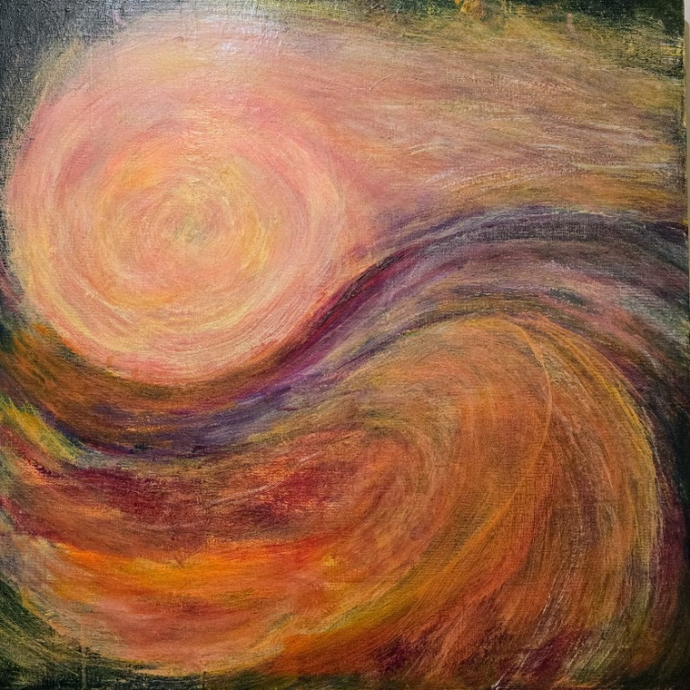There will be an opening reception for the exhibit with wine and cheese served on Friday, October 4 at 2:00 in the McGinley Room.

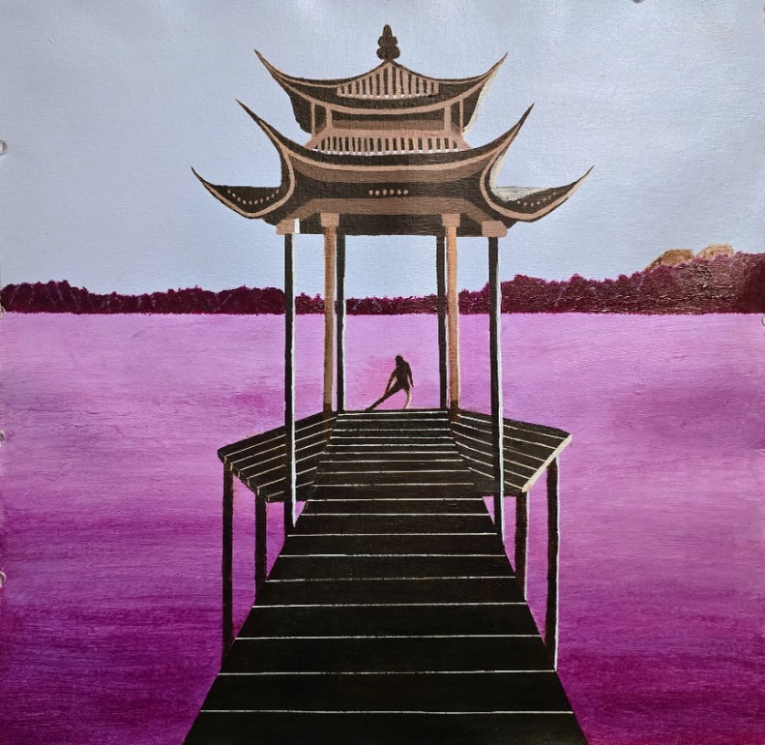

# Library Corner

## New Acquisitions September 2024

There were no new acquisitions for September.

## Reminders from the Library Committee

* **Looking for a specific book**: The binder on the table is up to date. You can easily search for any book in the library by title or author. The library also has a computer, which is a bit slow, with the information. The computer is not for personal use.
* **Returning a book**: Please do not put it back on a shelf but rather in the return books box. It is up to committee members to return a book to its proper place.
* **Donating a book**: Again, there is a box for donating books. As we have limited space on our shelves, please don’t donate paperbacks.
* **Other donations**: Do you want to get rid of a catalogue or magazine: Please don’t put it on our table. Take it and put it in the Recycle Bin. We try not to have clutter!

Library Committee  
Are you looking for an enjoyable book? Martha Nell Beatty, Yvonne Benedict, Pam Fischer, Gene Graham, or Kay Narron can help you.

## Cloistered: My Years as a Nun ~ By Catherine Coldstream

Reviewed by Trish Otstott

Catherine Coldstream pours her heart out in this incredible story of her life (12 years) in a cloistered monastery in England. Coming from a fairly dysfunctional household, she grew up accustomed to strange and missing family dynamics, seeking her own privacy, and choosing solitary enjoyments. When she entered the monastery, she was thrilled by the simple needs, the simple faith and the truth of the life of a nun. When the peace of the monastery changed into something intolerable, she bolted. This is the fascinating story of an earnest woman of faith and her life both inside and outside a cloistered monastery.

# Sage with some AI-rtistic license

